Lagged cross-correlation: GBPUSD and USDCAD
Method 12 / daily log returns / K_max=10 / Alpari D1 full available history

Study setup
Logical pair: GBPUSD , USDCAD
Broker symbols: GBPUSD_i , USDCAD_i
Snapshot: 2026-11-03_majors_alpari_D1
Timeframe: D1
Matched return window: 1999-01-05 to 2026-11-02 (UTC bar dates)
Matched return count n: 7205
Dropped unfinished last bar dated 2026-11-03 UTC after a tick-volume check against the prior complete day.
Lag definition: rho_X->Y(k) = Corr(x_t, y_{t+k}) on matched D1 bars
K_max = 10; headline lag k = 1 (both directions)
Complete matched rows (Excel): GBPUSD-USDCAD_Lagged_D1.xlsx
Complete matched rows (HTML table): GBPUSD-USDCAD_Lagged_D1_data.html

Method carried forward
Lagged cross-correlation measures Pearson correlation between matched daily log returns of close, ln(close_t / close_t-1), after shifting one series forward by k bars on the matched panel. Quotes are not inverted. rho_{X->Y}(k) = Corr(x_t, y_{t+k}) with n_k = n - k. K_max = 10 is fixed before estimation. The headline is the pre-specified lag k = 1 in both directions. k = 0 is the same-bar side check. The lag inside 1..10 with the largest absolute rho is stored as a descriptive column only; it is not a selected result. This is a linear screen, not proof of forecast edge, economic cause, or a trading signal.

Results (headline k=1)
rho_GBPUSD->USDCAD(1): 0.028713 (n=7204)
95% Fisher interval GBPUSD->USDCAD: [0.005624, 0.051771]
rho_USDCAD->GBPUSD(1): -0.040946 (n=7204)
95% Fisher interval USDCAD->GBPUSD: [-0.063979, -0.017871]
Same-bar rho(k=0): -0.456462
Largest |rho| among k=1..10 (descriptive only, not selected): GBPUSD->USDCAD k=1 rho=0.028713; USDCAD->GBPUSD k=8 rho=-0.048660

CCF table
k | rho_GBPUSD_to_USDCAD | n_GBPUSD_to_USDCAD | rho_USDCAD_to_GBPUSD | n_USDCAD_to_GBPUSD
0 | -0.45646241 | 7205 | -0.45646241 | 7205
1 | 0.0287131 | 7204 | -0.04094633 | 7204
2 | 0.00049925 | 7203 | -0.01531958 | 7203
3 | 0.00859376 | 7202 | 0.00801413 | 7202
4 | -0.00109999 | 7201 | -0.01713279 | 7201
5 | 0.02099192 | 7200 | 0.00925067 | 7200
6 | 0.02774275 | 7199 | 0.01689796 | 7199
7 | 0.02525576 | 7198 | 0.00132267 | 7198
8 | 0.00879974 | 7197 | -0.04865988 | 7197
9 | 0.01564602 | 7196 | 0.01734608 | 7196
10 | 0.01131104 | 7195 | -0.01059867 | 7195

Conclusion
At the pre-specified lag k=1 for GBPUSD and USDCAD, rho_{GBPUSD->USDCAD}(1) = 0.0287 (n=7204) and rho_{USDCAD->GBPUSD}(1) = -0.0409 (n=7204). Same-bar rho(k=0) = -0.4565. Largest |rho| among k=1..10 is descriptive only: GBPUSD->USDCAD at k=1 (0.0287); USDCAD->GBPUSD at k=8 (-0.0487). This is a linear screen, not forecast proof or a trading signal.

Charts
Daily closes

Daily log returns

CCF both directions k=0..10
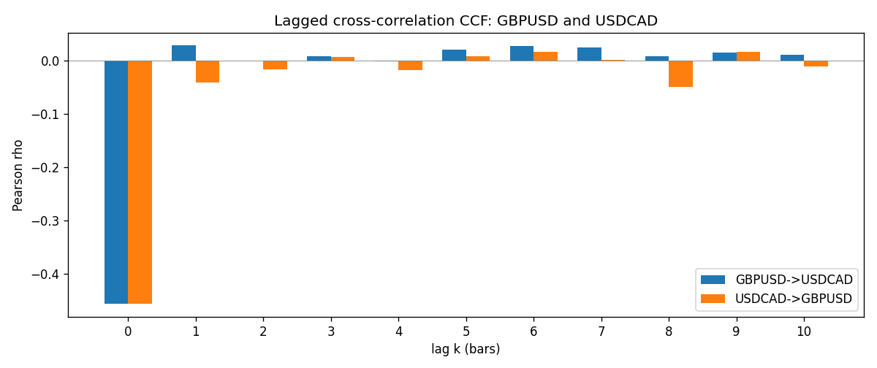

Data report
Every matched row is stored in the sibling Excel workbook named GBPUSD-USDCAD_Lagged_D1.xlsx (sheet matched_rows). The CCF sheet holds rho(k) for k=0..10. Embedding all rows as a Word table is impractical; the Word file holds column summaries and the first and last 15 rows.
Columns: time, GBPUSD_open, USDCAD_open, GBPUSD_high, USDCAD_high, GBPUSD_low, USDCAD_low, GBPUSD_close, USDCAD_close, GBPUSD_tick_volume, USDCAD_tick_volume, GBPUSD_spread, USDCAD_spread, GBPUSD_real_volume, USDCAD_real_volume, GBPUSD_log_return, USDCAD_log_return
Column summaries (matched calculation rows)
column | count | mean | std | min | 25% | 50% | 75% | max
GBPUSD_open | 7205 | 1.5161639 | 0.2182756 | 1.06854 | 1.32505 | 1.51142 | 1.63205 | 2.1066
USDCAD_open | 7205 | 1.2670469 | 0.16900802 | 0.9168 | 1.119 | 1.29857 | 1.3723 | 1.6183
GBPUSD_high | 7205 | 1.5224596 | 0.21884187 | 1.08366 | 1.32981 | 1.5182 | 1.6384 | 2.1161
USDCAD_high | 7205 | 1.2719479 | 0.16896591 | 0.9336 | 1.1234 | 1.30394 | 1.3769 | 1.619
GBPUSD_low | 7205 | 1.5098441 | 0.21750249 | 1.03518 | 1.31956 | 1.50336 | 1.62444 | 2.0983
USDCAD_low | 7205 | 1.2624879 | 0.16904619 | 0.9056 | 1.1144 | 1.29361 | 1.36793 | 1.6102
GBPUSD_close | 7205 | 1.5162333 | 0.21823062 | 1.06879 | 1.3252 | 1.5114 | 1.6322 | 2.1065
USDCAD_close | 7205 | 1.2670655 | 0.16898286 | 0.916 | 1.11851 | 1.29871 | 1.37253 | 1.6137
GBPUSD_tick_volume | 7205 | 94776.836 | 153518.92 | 62 | 9986 | 52867 | 91739 | 1273370
USDCAD_tick_volume | 7205 | 80835.261 | 147176.39 | 37 | 5509 | 40849 | 71515 | 1410818
GBPUSD_spread | 7205 | 26.978348 | 19.192834 | 0 | 11 | 20 | 50 | 50
USDCAD_spread | 7205 | 23.508952 | 18.282466 | 0 | 9 | 17 | 40 | 60
GBPUSD_real_volume | 7205 | 3.5541156e+09 | 8.441481e+10 | 0 | 0 | 0 | 0 | 2.4038164e+12
USDCAD_real_volume | 7205 | 1.8330194e+10 | 9.6578305e+10 | 0 | 0 | 0 | 0 | 2.5751613e+12
GBPUSD_log_return | 7205 | -2.188e-05 | 0.00563988 | -0.08388241 | -0.00312535 | 3.221e-05 | 0.0031749 | 0.03112653
USDCAD_log_return | 7205 | -1.219e-05 | 0.00514402 | -0.03859748 | -0.00283601 | 4.92e-05 | 0.00272763 | 0.03436319
First 15 matched rows (selected columns)
time | GBPUSD_close | USDCAD_close | GBPUSD_log_return | USDCAD_log_return
1999-01-05 | 1.6547 | 1.5123 | -0.0028966287 | -0.010131666
1999-01-06 | 1.6537 | 1.5118 | -0.00060452184 | -0.0003306769
1999-01-07 | 1.6502 | 1.5141 | -0.002118709 | 0.0015202092
1999-01-08 | 1.6405 | 1.511 | -0.0058954193 | -0.0020495197
1999-01-11 | 1.6312 | 1.5057 | -0.0056851331 | -0.0035137769
1999-01-12 | 1.6349 | 1.5157 | 0.0022657001 | 0.0066194721
1999-01-13 | 1.6499 | 1.5226 | 0.0091330396 | 0.0045420214
1999-01-14 | 1.6531 | 1.5332 | 0.0019376331 | 0.0069376546
1999-01-15 | 1.6502 | 1.5245 | -0.0017558204 | -0.0056905671
1999-01-18 | 1.6522 | 1.526 | 0.0012112405 | 0.00098344542
1999-01-19 | 1.6553 | 1.5302 | 0.0018745281 | 0.002748513
1999-01-20 | 1.6472 | 1.5211 | -0.0049053846 | -0.0059646885
1999-01-21 | 1.6524 | 1.5146 | 0.0031518998 | -0.0042823796
1999-01-22 | 1.6565 | 1.5184 | 0.0024781662 | 0.0025057712
1999-01-25 | 1.6585 | 1.5197 | 0.0012066366 | 0.00085579808
Last 15 matched rows (selected columns)
time | GBPUSD_close | USDCAD_close | GBPUSD_log_return | USDCAD_log_return
2026-10-13 | 1.32534 | 1.4214 | 0.0036434319 | -0.0046395653
2026-10-14 | 1.31884 | 1.42356 | -0.0049164679 | 0.0015184751
2026-10-15 | 1.32757 | 1.41843 | 0.0065976411 | -0.0036101503
2026-10-16 | 1.33257 | 1.41357 | 0.0037592051 | -0.0034322068
2026-10-19 | 1.33024 | 1.41091 | -0.0017500314 | -0.0018835331
2026-10-20 | 1.3377 | 1.40569 | 0.0055923442 | -0.0037066008
2026-10-21 | 1.33937 | 1.4045 | 0.0012476328 | -0.00084691787
2026-10-22 | 1.33967 | 1.40081 | 0.00022396082 | -0.0026307268
2026-10-23 | 1.33684 | 1.40085 | -0.0021146949 | 2.85545e-05
2026-10-26 | 1.33359 | 1.40093 | -0.0024340661 | 5.7106554e-05
2026-10-27 | 1.33044 | 1.40449 | -0.0023648393 | 0.0025379458
2026-10-28 | 1.33254 | 1.39911 | 0.0015771808 | -0.0038379274
2026-10-29 | 1.33733 | 1.39895 | 0.0035881935 | -0.00011436495
2026-10-30 | 1.33913 | 1.39751 | 0.0013450605 | -0.0010298736
2026-11-02 | 1.3406 | 1.39837 | 0.0010971256 | 0.00061519094

